**How to restore a Database using SQL Server Management Studio.**

**How to restore a database using SQL Server Management Studio Express.**

First, navigate to **Start** -> **Programs** -> **Microsoft SQL Server xxxx** -> **SQL Server Management Studio**

Upon opening the program, you should be prompted with a **Connect to Server** box. Fill out the fields with your database information.

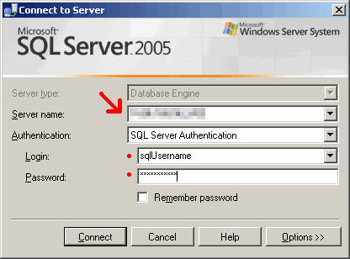

The **Server Name** field is the IP or server name of the Database Server.

The **Authentication** field should be **SQL Server Authentication** by default.

The **Login** is “sa”.

Contact IED Technical support for the password.

Upon connecting, you will see a window similar to the picture below. On the left, select/expand **Databases** and find the database called ‘Prizm’

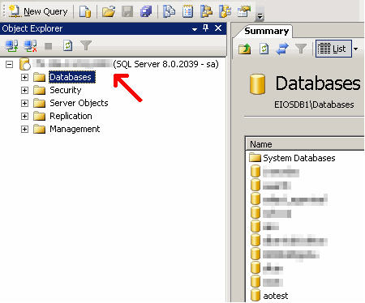

Right click on ‘Prizm’ and go to **Tasks** -> **Restore** -> **Database**

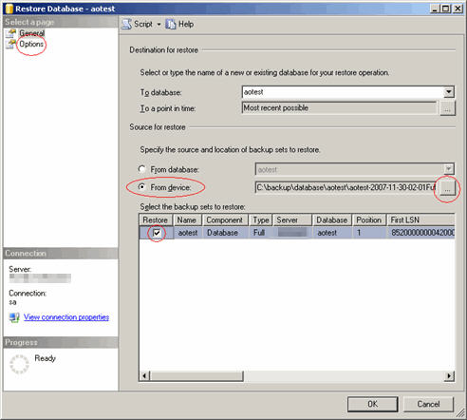

Select **From device** and click the small grey box on the right labeled ”**...”** . A window will pop up, Click **Add** and browse to “c:\iedsqldata\backup” (the location of your .bak file). Then select the file “Prizm.bak” and click **OK**.

Check the checkbox under the column **Restore** next to the database information in the bottom pane.

Go to the **Options** (top-left).

Check **Overwrite the existing database**.

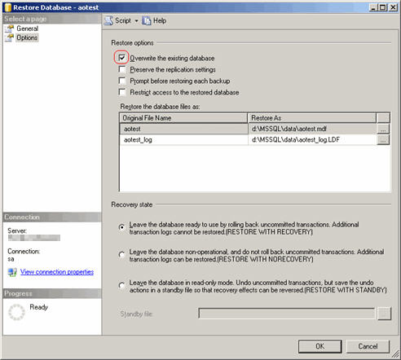

Click **OK** to begin the database restoration.

Now that your database is restored, we have to make sure the users associated with the database have proper permissions.  
  
Collapse the **Databases** directory in the left window. Expand the **Security** folder and go to **Logins** and find the “ied” user associated with the database. Right click on the Username and go to **Properties**.

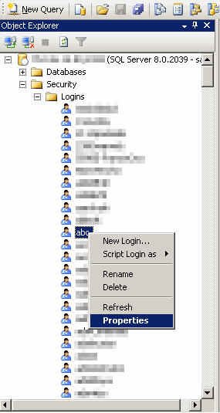

Go to the **User Mapping** on the top-left. Locate your “Prizm” in top-right window pane list and make sure the checkbox is checked next to it. Once “Prizm” is selected, make sure the **db_owner** checkbox is checked in the bottom window pane and click **OK**.

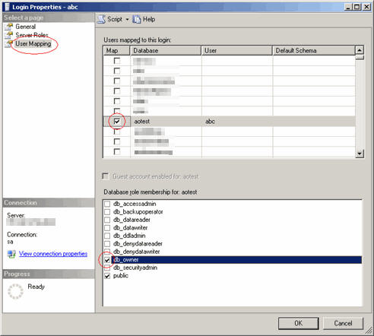

Repeat the above steps for the “prizm” user.

If this has completed with No Errors then you have successfully restored your database!