System Supervision – Post Installation Setup Utility

Release 1.4.1.0 of the System Supervision Service comes with a utility program that allows one to easily enable/disable features of the System Supervision Service. An executable file called “PostInstallSetup.exe” can be found in the folder that the Service was installed in (typically, this is C:\IED\Services\SystemSupervision). Executing the program opens the window shown in Figure 1.

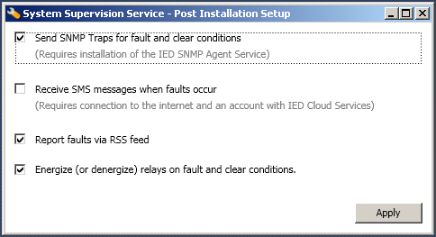
Figure 1: System Supervision Service - Post Installation Setup (Main Screen)

In the past, one had to reinstall the service and pick the features that were desired through the installer. An alternate approach was to enable missing features via hand editing of the exe.config file. Needless to say, the processes available were cumbersome, error-prone, or impractical.

The utility program allows one to enable/disable the following features:
- Fault reporting via SNMP traps.
- Fault reporting via SMS messages.
- Fault reporting via RSS feed.
- Relay activation on fault and clear events.

(Additional services and/or subscriptions may be necessary to fully activate some of the features.)

Simply, check or uncheck the features of System Supervision and click the “Apply” button. The utility will automatically shutdown the System Supervision Service, commit changes to the exe.config file, and start the System Supervision Service back on.

The utility will shutdown with an error popup box when attempted to run on a computer that does not have the System Supervision Service installed.

