**Globalcom Ambient Analysis**

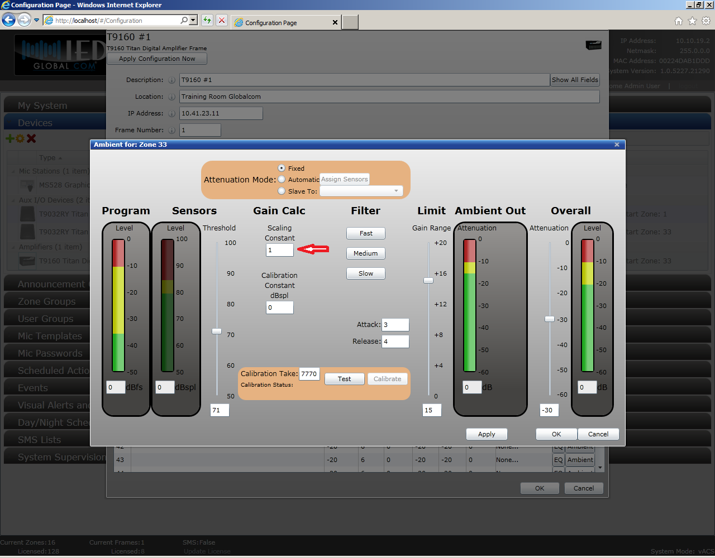

In this figure, the scaling constant is set to 1. This means that for every 1dB of increased ambient SPL above the threshold, there will be 1dB of gain added to the system. Increasing the constant will lower the added gain. Example: Scaling constant set to 2 dB will add 1db of gain for every db 2dB of increased ambient SPL above the threshold.