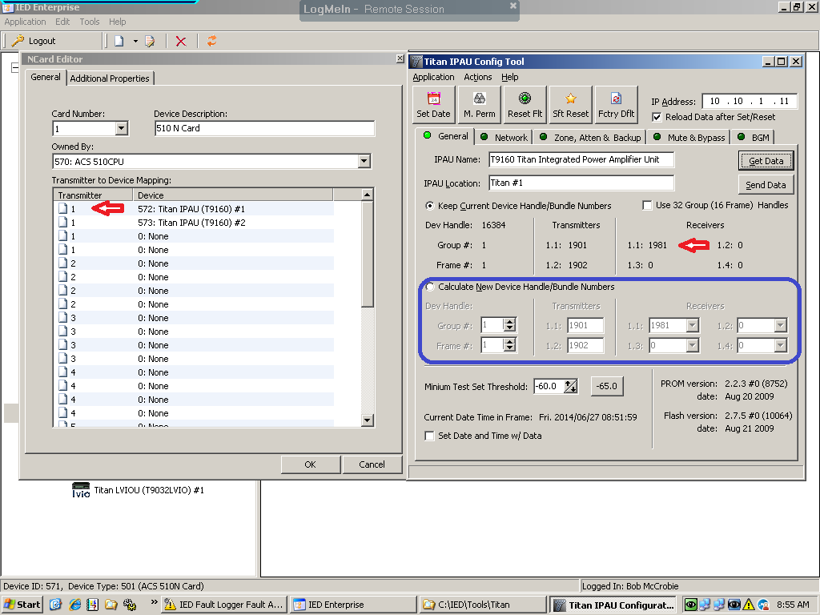

In the figure above the red arrows indicate the N-card transmitter and Ipau receiver settings respectively.

The blue box represents the area that, when selected, will allow changes to be made to the Group number (which is the ACS number), the frame number (which is the frame number as added in Enterprise), the transmitter, and receiver assignments.

The transmitter and receivers are defaulted to respond to the group and frame numbers. In the case of DTW, the Ipau receiver numbers have been changed to use transmitters 4 and 5 on the second N-Card.

**Rules of thumb when configuring N-cards and Ipau frames:**

Ipau receiver number must match the transmitter number on the N card for that frame. 1981= transmitter 1. 1982= transmitter 2. Etc.

There are 4 channels per transmitter on the N-Card. There are 4 receiver channels per Titan frame.

The frame number (in Enterprise) and the last octet of the frame ip address should be the same. Ex; xx.xx.xx.1= Frame #1. xx.xx.xx.22= Frame #12. xx.xx.xx.33= Frame #23.