Creating Multiple Analog Backup Inputs on a T9160 Amp Frame
Introduction
Often, input 8A is configured as the analog backup input on a Titan T9160 frame. There has been a request to allow more than one input to be used for this function. This document describes how to configure 3 inputs for this. These inputs are mixed together equally, although it is possible to adjust volume levels so one input is louder than others.
Approach
The approach used is to insert a 3-to-1 mixer ahead of the Input Router object in the T9160, taking in inputs 8A, 7A and 7B. The output of the mixer is feed into the Input Router in place of Input 8A’s signal. So, one would still select 8A for routing to the Priority Input as one normally does when configuring the analog backup function. Below is a section of the Object Block Diagram with the new 3-to-1 mixer added in.
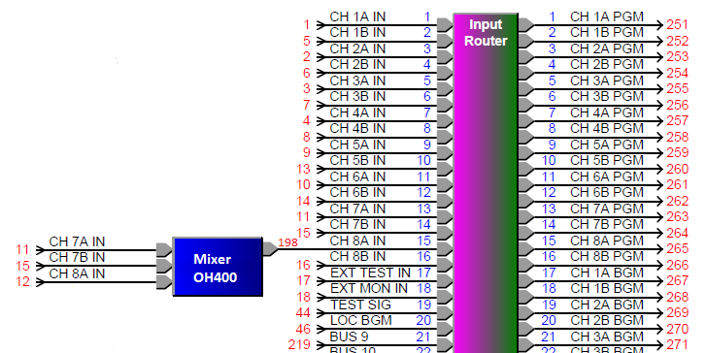
How to Implement
This is accomplished by downloading an IOB file which defines the new Mixer object and its inputs and modifies the CH 8A IN of the Input Router. This file is called Analog_Backup_Mixer.IOB. Should this file become lost, it can be re-created by copying the text below into a text editor and saving as this IOB file. (Be sure word wrapping is off. This should appear in the final file as Six lines of numbers and a line with #’s at the end.
Then, one uses ViewProp to link to the T9160 frame and do the following steps:
- Click on the up/download menu (▼ button) and select “Download Objs from File”.
- When prompted to delete all objects first, click on the No button.
- After the download, click on the Make Perm button
- After a few seconds, click on the Reset button, following by the Yes button on the confirmation pop-up.
After the T9160 frame reboots, it should now have the additional 3-to-1 mixer in the signal chain as described above.
Contents of Analog_Backup_Mixer.IOB
59,400,65535,0,(14,2,"Analog Backup Mixer"),(13,6,1),(174,8,"[0,0,0,0,0,0,0,0,0,0,0,0,0,0,0,0]"),(1,11,0),(1,2068,0),(151,3072,0.000000),(1,3073,0)
4,401,400,0,(14,2,"Mixer Output"),(13,6,1),(174,8,"[0,0,0,0,0,0,0,0,0,0,0,0,0,0,0,0]"),(1,11,0),(13,2048,0),(1,2068,127),(2,3074,198),(131,4096,0.000000),(13,4097,0),(155,4098,1.000000)
72,402,400,0,(14,2,"8A Input"),(13,6,1),(174,8,"[0,0,0,0,0,0,0,0,0,0,0,0,0,0,0,0]"),(1,11,1),(13,2048,0),(1,2068,127),(2,3073,12),(131,4096,0.000000),(13,4097,0),(155,4098,1.000000),(1,5121,0),(131,5122,-20.000000),(1,5123,255),(1,5124,0),(163,5125,0.000000),(163,5126,0.000000)
72,403,400,0,(14,2,"7A Input"),(13,6,1),(174,8,"[0,0,0,0,0,0,0,0,0,0,0,0,0,0,0,0]"),(1,11,2),(13,2048,0),(1,2068,127),(2,3073,11),(131,4096,0.000000),(13,4097,0),(155,4098,1.000000),(1,5121,0),(131,5122,-20.000000),(1,5123,255),(1,5124,0),(163,5125,0.000000),(163,5126,0.000000)
72,404,400,0,(14,2,"7B Input"),(13,6,1),(174,8,"[0,0,0,0,0,0,0,0,0,0,0,0,0,0,0,0]"),(1,11,3),(13,2048,0),(1,2068,127),(2,3073,15),(131,4096,0.000000),(13,4097,0),(155,4098,1.000000),(1,5121,0),(131,5122,-20.000000),(1,5123,255),(1,5124,0),(163,5125,0.000000),(163,5126,0.000000)
33,61115,61100,0,(14,2,"Frame Input 8A"),(14,3,"OH EEBB"),(13,6,1),(174,8,"[0,0,0,0,0,0,0,0,0,0,0,0,0,0,0,0]"),(1,11,15),(13,2048,0),(1,2068,127),(2,3073,198)
############# BLOB Data to Follow ############

