Integrating GLOBALCOM® with
Windows Security and Active Directory
Applicable GLOBALCOM® version: GCK SP3 and later.

The AtlasIED GLOBALCOM controller contains an embedded windows computer at its core. When you access the controller you must first log into windows and then log into the GLOBALCOM SMC (System Management Center) web page. Our typical installations prior to GCK SP3 have always allowed a single login to log into Windows on the controller. Access was then limited to the SMC application using one of three user accounts (Admin, Installer, User). This was concerning to IT departments because the username and password information to access the controller and the GLOBALCOM SMC application needed to be given to everyone requiring access and was typically the same across any systems installed in the facility. When someone left the organization or changed roles, they were still in possession of access information to the GLOBALCOM controller(s) or login information needed to be changed across all affected systemsand redistributed to anyone needing access.

In order to improve security and flexibility, AtlasIED GLOBALCOM® has integrated windows based security for user authentication and authorization. Leveraging industry standard security models, IT departments can now manage access to the AtlasIED GLOBALCOM® Announcement Control System by integrating existing authorization levels with Microsoft Active Directory roles. This feature is particularly beneficial to large enterprise systems by allowing them to manage access to multiple GLOBALCOM® controllers from one central location. This benefit is not lost on smaller installations. A single GLOBALCOM® controller can be added to a local windows domain for centralized user management, or, access can by controlled by using the existing windows based security model built into the controller. This new security model will strengthen the security used to access the GCK System Management Console (SMC).

This document is intended to guide IT departments on integrating the GLOBALCOM® controller with Windows Security and Active Directory. We will first discuss setting up Windows Security, users and roles on the GLOBALCOM® controller. After that we will discuss adding the controller to a Windows Domain and configuring it for use with Active Directory domains.

Configuring Windows Security on GLOBALCOM® Controller

GLOBALCOM® controllers that ship with GCK SP3 will already be configured to use Windows Security. An installer application is available on the AtlasIED web site that will automatically create the default users and groups needed to access the GCK SMC. If for some reason, the installer didn’t run properly, these can be manually configured via the procedure described at the end of this document. Normally, these steps should NOT be necessary. The Users and User Groups established by the installer are listed in the table below.

Default GCK Users | Default GCK User Groups
Admin  Installer  User | GCK Advanced Users  GCK Installers  GCK Users

These are defaulted to have passwords that match the user names, but can be changed by any Windows user with Administrator level permissions.

Configuring the GLOBALCOM® controller to use Active Directory

Configuring users and groups on Active Directory Domain Controllers are done in much the same way as outlined above, but should be handled by your IT Department or Network Administrator. The GLOBALCOM® audio controller should be added to the domain, but the controller should NOT be a part of any computer based policies. This is because some policies may prohibit the software’s ability to perform certain functions.

The GLOBALCOM® controller has been tested with the Windows embedded service packs and updates currently installed on it and should not be automatically updated. It is also not recommended that Anti-Virus software be enabled on the controller. If a facility would like to do manual Windows updates, it would be there responsibility to verify proper system operation after the update, possibly rolling the update back if problems are found. Similarly, although AtlasIED does not recommend the use of any particular Anti-Virus package, if the user/owner wants to try installing their facility’s package and test system operation afterward, they may do so. If the user/owner encounters problems with either Windows updates or Anti-Virus packages, technical support from AtlasIED is available at the standard rates to assist in diagnosing the issue.

Once the controller has been configured with the default windows users and groups or has been added to the domain, the SMC can be configured to use the appropriate method for user validation. The next section will go into more detail on adding Windows or Active Directory groups to GLOBALCOM® security roles.

Configuring GLOBALCOM® security roles

Now that the GLOBALCOM® controller has been either added to an Active Directory Domain or it’s local windows security has been configured with the proper users and groups, it is possible to map the appropriate user groups to the security roles built into the GLOBALCOM® SMC. By default, the SMC security roles are mapped to the user groups configured by the HTTPS Updater installer (described in the Appendix). To start, on should launch the SMC using Microsoft Internet Explorer and navigating to the URL: https://<controller_IP_address> . The first time, there may be a notification that the certificate is unsigned. This is normal, because SMC uses a self-signed certificate. One should accept the certificate and add it to the exceptions in Internet Explorer. (With some versions of Internet Explorer, there are extra hurdles to get over in order to do this. There is some guidance available from AtlasIED should problems be encounterd on this.)

When prompted, for a username and password, log into the admin account using the username of “admin” and the default password of “admin”. This may be different if one has changed the default installed Windows.

Once you are logged into an account with administrative permissions in the SMC, navigate to the “Admin” tab and select “Role Mapping” from the menu on the left side of the window. Here you can choose between using Local Windows security or Active Directory Domain security. By default, local windows security will be used. The three default groups that the SMC recognizes are listed in the roll mappings grid on the right. Notice that these are the same user groups created at the beginning of this document. Pressing the “Retrieve” button under “Available Groups” will retrieve a list of user groups either for the local GLOBALCOM controller, or for the domain that the controller is a member of depending on the type of security model selected. The “Use Domain Authentication” / “Use Local Authentication” button will toggle between the two security models. Using the text box under “Add New Group” will allow you to add a user group prior to creating it on the local controller or the Active Directory Domain.

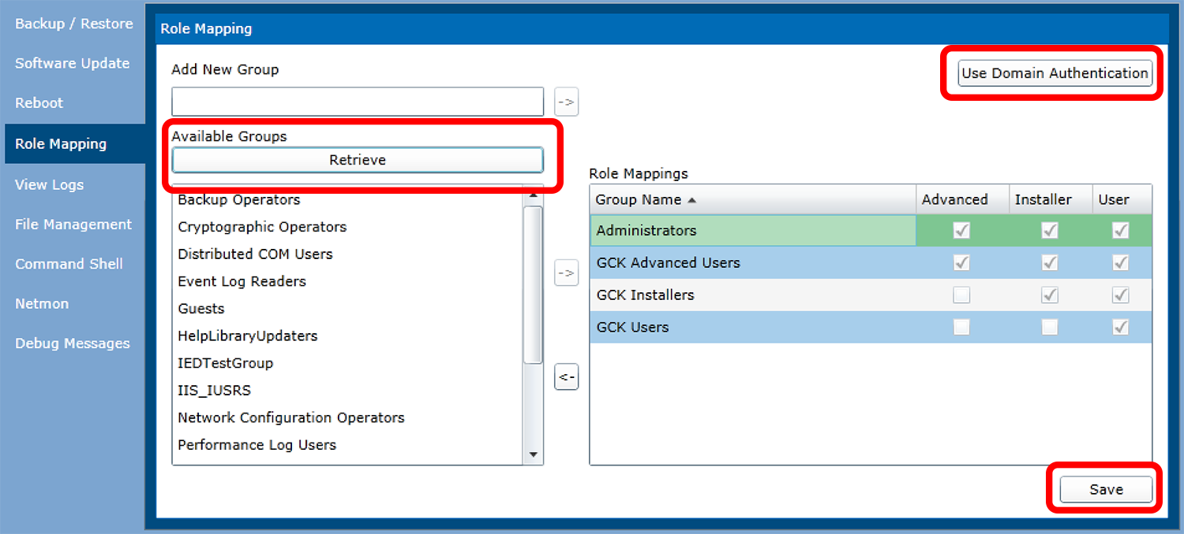
Figure: Map user groups to SMC Security Roles.
To map user groups to the appropriate security roles, first select the security model you are going to use. The default model is Windows Security on the local GLOBALCOM controller. Pressing the “Retrieve” button will retrieve all user groups currently configured on the local controller. The default security groups and their selected roles will already be populated in the “Role Mapping” grid to the right. Select additional groups you wish to map SMC roles to and either double click on them, or press the button with the arrow pointing right to move that group over to the “Role Mappings” grid. Now select the appropriate security role for the group you just moved over. Selecting a check box for a role will also select any lower security roles. Now any local windows users that are members of a configured security group will have the selected roles. Now click the “Save” button to apply the changes you have just made. New role mappings will not take effect until the changes are saved. In the above example, anyone that belongs to the “Administrators” security group will have “Advanced” security permissions within the SMC.

The Active Directory Domain security model is configured in very much the same way as the Local Windows security model. Clicking the button “Use Domain Authentication” will toggle between using windows security on the local controller and using the Active Directory Domain security on the domain that the controller is a member of. After clicking “Use Domain Authentication”, click the “Retrieve” button under “Available Groups”. This will bring back a list of all user groups configured on the Active Directory server. Select the groups you would like to add SMC security roles to and move them to the “Role Mapping” grid to the right. There is no restriction on the number of user groups that can be added to the role-mapping grid. Select the security levels for the newly added user groups and then click the “Save” button to apply the changes.

At this point the appropriate security model should be configured on the GLOBALCOM controller. Users can now navigate to the GLOBALCOM SMC using Microsoft Internet Explorer. Now, when the user logs in, their local windows account or domain login should be used. The controller will then check the user groups the user is a member of to determine the security level accessible within the SMC.

Appendix: Manually Configuring GLOBALCOM® security roles

This section covers manual configuration of the default users and groups required to access the SMC, should it be necessary. It may also serve as a tutorial on what was done automatically by the IED-provided installer (SMC_HTTPS_Updater.exe).

Default GCK Users | Default GCK User Groups
Admin  Installer  User | GCK Advanced Users  GCK Installers  GCK Users

Creating the default users and groups will need to be done on the GLOBALCOM® controller. Log into the controller either by using a connected keyboard, mouse, and monitor or by accessing the controller using Remote Desktop. Open the “Local Users and Groups Management” tool by clicking on the start menu, then right clicking on “computer” and selecting “manage”. You can also open the tool directly by typing lusrmgr.msc in the search box at the bottom of the start menu. When the window opens, under “Computer Management”, “System Tools”, expand “Local Users and Groups”. Select “Groups”, then right click on “Groups” and select “New Group”. In the New Groups dialog, enter the name of the group, i.e. “GCK Advanced Users”. When the group name is entered, click the “create” button. The name you just entered in the dialog will go away ready for you to create another group. Create the remaining user groups and then close the dialog box. You will now see the new groups are now added to the system.

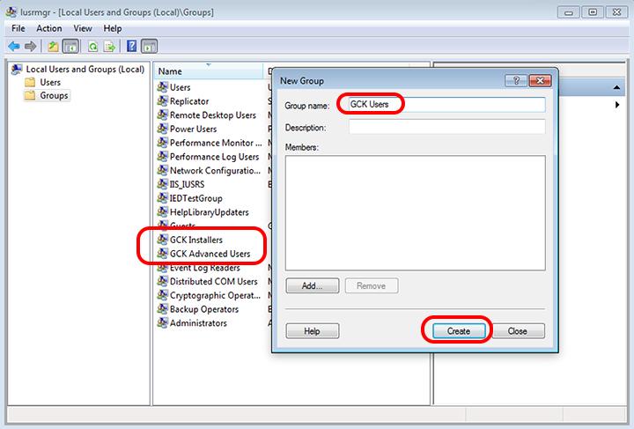
Figure : Create default GCK user groups

Once the default user groups have been created. Create the default users for GCK SMC. Right click on the “Users” folder to the left and select “New User”. Follow the same process for adding users as you did for adding groups. Fill in the user name, full name (optional), description (optional), and password. Un-check user must change password at next login, and check the selection for the password never expires. Press the “Create” button to create the user. Follow this process for the three default users “admin”, “installer” and “user” and then press the “Close” button. You will then see the default users in the list.

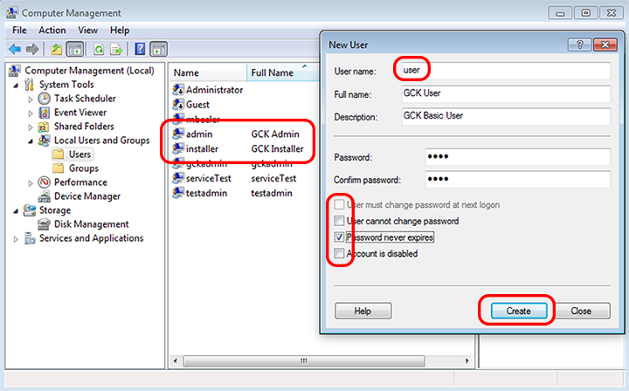
Figure: Create default GCK users.
Now that the default users and groups have been crated, we now need to add the users to the required groups. Double click on the user you would like to add to a group. Select the “Member Of” tab. Click the “Add” button, then click the “Advanced” button, then finally click the “Find Now” button. A list of user groups will be shown at the bottom of the dialog. Select the appropriate user group. In this case the “GCK Advanced Users” group. Once the group (or groups) is selected, click the “OK” button. Repeat this process adding the appropriate groups to the desired users.

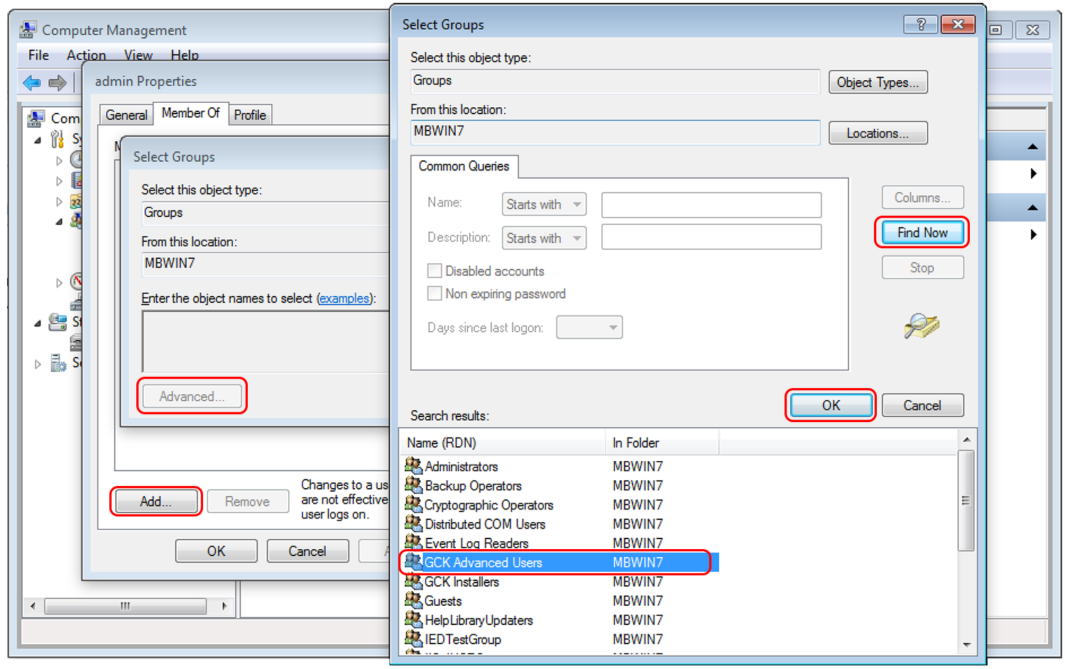
Figure: Add GCK Groups to appropriate users.

The default users are now configured on your controller. Again, AtlasIED should make an installer available to do this automatically. The purpose of this section was to outline the manual process of creating these default users and groups. This process also applies to adding additional users and assigning them to the appropriate user groups for more granular user control.

