Fixing 550CS (or 5450CS) Stations Where Template Does not Display

Ver 1 31 July 2017
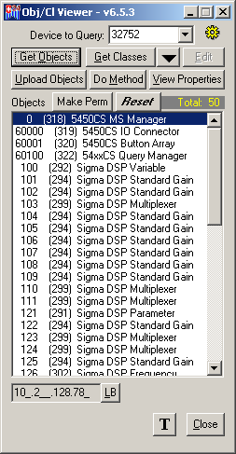
Introduction
There have been a few instances where 550CS touch screen stations have come out of Production and they are not able to display a downloaded template. The cause for this is partial configuration which tells the firmware that it does not have a touch screen, but has a pushbutton human-machine interface instead. This document describes a way to address this problem using ViewProp. The basic steps are as follows:
- Change the Device Type of the station
- Make the change permanent
- Reset the device
It should then come up and re-request a download of the template from the GLOBALCOM.IP controller (IP108 or equivalent) after which it should display the assigned template and screen header text.
Change the Device Type
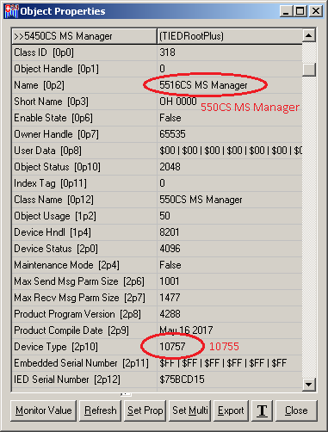
Bring up ViewProp and establish communication with the 550CS. One should see a list of objects such as in the example at upper right. One should double-click on the top object (5450CS MS Manager) to bring up the properties window as shown below right. Notice there are two properties that will appear different than expected for this situation. These are highlighted by the red ellipse in the example shown. The expected values are in red text beside them.
One should go to the Device Type (2p10) property and change the value from 10757 to 10755. Then hit the Set Prop button at the bottom. One can also hit Refresh to be sure the property was successfully sent to the device.
Then hit Close to exit the Object Properties window.
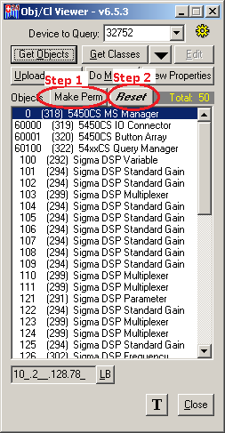
Make Permanent
On the top of the main ViewProp window, hit the Make Perm button, and wait a few seconds for it to process internally.
Reset the Device
After the make permanent operation has had time to process, hit the Reset button and “Yes” the pop-up Yes/No confirmation dialog box.
Now, you should see the screen blank and after a while come back. Sound afterward (less than one minute), the device should go into the update mode, where the GLOBALCOM.IP controller is downloading the assigned template to the station. After the update, the template should appear on the 550CS.

