Special Network Switch Configuration How-To’s

Ver 1.0 23 Feb 2018
Introduction
This white paper describes how to set up network switches to perform some special functions, such as mirroring a port for Wireshark capture, configuring for Dante audio, and setting up VLANs. Exactly how will vary by switch brand and model. The examples shown in this document are for the Cisco Small Business SG300 series switches which we use extensively in Engineering.
Getting Started
The SG300 series switches are configurable via web pages hosted on the switch. To access the configuration pages, one need to direct a web browser to the IP address of the switch and login. There are many different situations and cases for accessing the pages described in the manual from Cisco (“SG300 Series Admin Guide”). This document describes the most common.
From the factory, the SG300 series switch comes with an IP address of 192.168.1.254. If this is the current address of the switch, then the power LED will be flashing. If it has found a DHCP server (e.g., because it is on the IED house network) or been assigned a permanent IP address, then the power LED will be on solidly. One must know what this address is in order to access the switch. One could try PING a range of addresses to find out
If one believes it does not (yet) have a permanent address, then one might want to get the switch to revert back to the default address by moving it to a private network or direct connection to a computer to be used for configuration, and then power cycle the unit. Once the power LED is flashing, one can access the switch at the default IP address. If one wishes to access the switch when it is placed back on a network with a DHCP server, one should first assign it a permanent IP address, as described below.
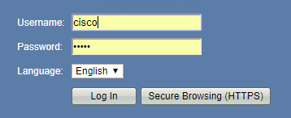
To access the web pages, simply type the switch’s IP address into the address bar of a web browser, followed by the [Enter] key or go button on the browser. One should first see a login prompt, such as shown at right. The default username and password are cisco. Enter these followed by clicking on the Log In button. If a different login account has been defined, one will need to know what that is, or go through the password recovery scheme described in the Admin Guide.
If this is the first time you have accessed the switch, or the switch has been recently reset to factory defaults, you will see a Set Password screen (only) such as shown below. Note, this can also happen if you change the switch’s Mode from Layer 2 to Layer 3, or back (see next section). If one wishes to leave the switch with the default, weak password, simply check the Disable box and then the Apply button as shown in the figure.
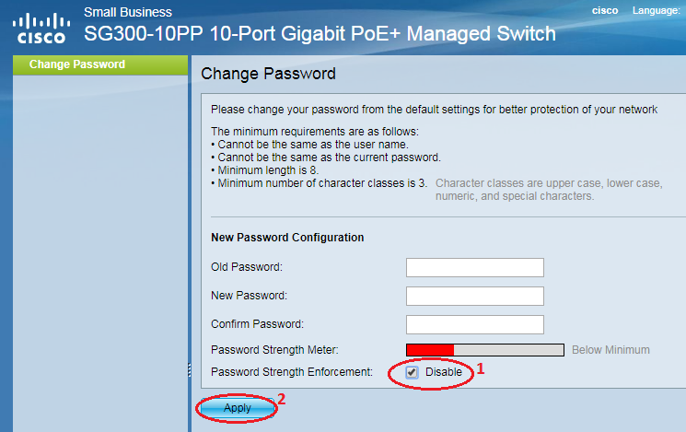
Reset to Defaults
If one cannot determine the IP address of the unit or has forgotten the password, it is possible to manually reset the SG300 series switch to factory defaults. The steps to do this are as follows:
Step 1. Disconnect all Ethernet cables from the switch.
Step 2. Using a pin or paper clip, press and hold the Reset button on the switch for 15 to 20 seconds.
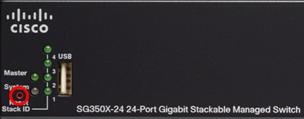
Step 3. Once all the port LEDs light up, release the Reset button.
Step 4. Wait for the switch to complete the reboot cycle and reconnect everything
Now, one should be able to connect at the default IP address and use the default login to get access.
Setting the Switch Mode
The switches come from the factory set for Layer 2 (L2) System Mode. This is fine for just hooking things up in your office for testing. You can even do port mirroring and set up Quality of Service (QoS) for optimum Dante performance with the switch in this mode. However, if you want to set up VLANs and have the switch do routing between the VLANs, you must put it into Layer 3 (L3) mode. VLANs still can be set up in L2 mode, but then one most connect an external router to do the layer 3 routing between VLANs. In most test setups in your office, these routers aren’t available, so it would be best to just set up the switch to do the routing, too. To change the switch System Mode, one should click on: (1) Administration section, (2) System Settings topic, (3) System Mode radio button of choice and then (4) the Apply button.
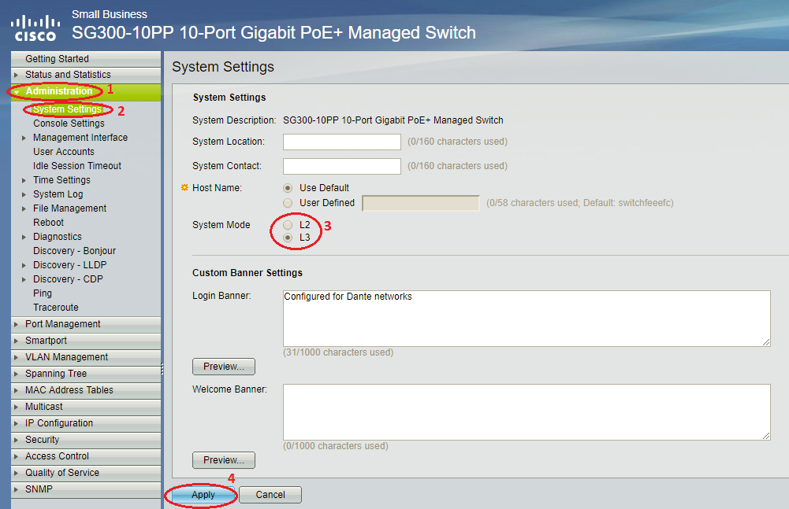
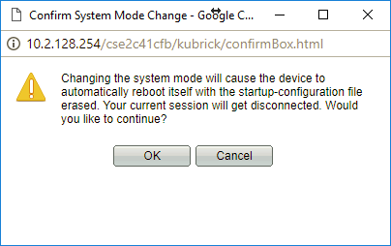
After clicking on the Apply button, one will get the warning/confirmation prompt shown at right. Click on the OK button, and go out for a smoke, if you have ‘em. It takes these switches several minutes to reboot.
After the reboot, switch will be back to its default 192.168.1.254 IP address, or will grab a DHCP address if it can. If the switch already had a permanent IP address, this will be lost, and one will have to re-direct the browser to the default or new DHCP address following the reboot.
Set a Permanent IP Address
How to set a permanent IP address depends on whether the switch is in Layer 2 or Layer 3 mode. This is because for a layer 3 switch, there is an IPv4 section under IPv4 Management and Interfaces that has possibly multiple IPv4 interfaces (addresses) for the various VLANs managed by the switch. But IP addresses is a layer 3 construct. How can a layer 2 switch have a layer 3 IP address? The answer is the switch has a hack/exception it puts in, but now under the Administration section, where one can define a IPv4 interface for switch management only.
Layer 2 Switch Mode IP Address Setting
To set a permanent IP address for a switch in Layer 2 mode, one should click on (1) Administration section, (2) Management Interface subsection, (3) IPv4 Interface topic. On the right are edit controls for setting up the permanent address.
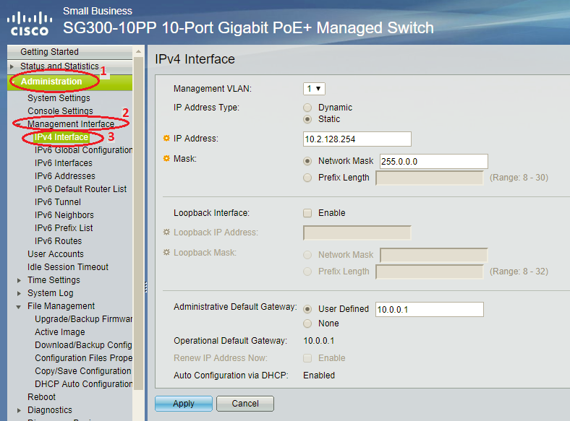
Once set, one clicks on the Apply button. This brings up the Success Message as shown below.
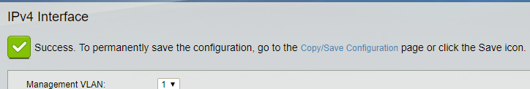
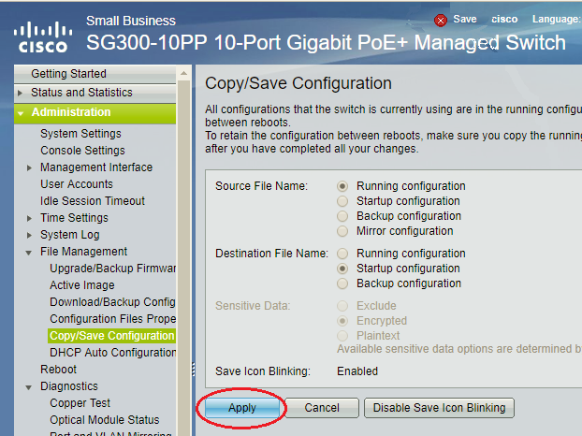
To make this change permanent, one should click on the blue text “Copy/Save Configuration” shown in the success message. This will first prompt you to auto-close the dialog box, to which you should approve. Then, it will take you to the section in the switch configuration for copying the current configuration into the startup/default configuration, as shown in the screen shot below. Click on the Apply button here to make these changes permanent.
Layer 3 Switch Mode IP Address Setting
To set a switch that is in layer 3 mode to have a permanent IP address, one goes to IP Configuration section, IPv4 Management and Interfaces subsection, and the IPv4 Interfaces topic. On a new switch with defaults set up, one will see both the DHCP and default IP address entries as shown below. These cannot be edited. Instead, one should add a new permanent IP address by clicking on the Add… button. (After it is added, the switch automatically deletes these two IPv4 Interfaces.)
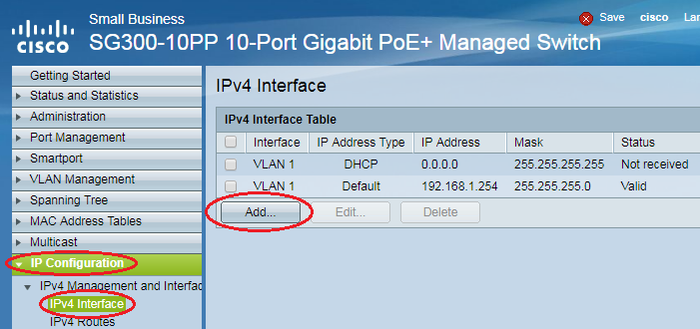
Clicking on the Add… button brings up the pop-up shown below. One should fill out the settings for the default VLAN 1, similar to the example below. (You IP Address and Network Mask will vary.) Then, one should click on the Apply button.
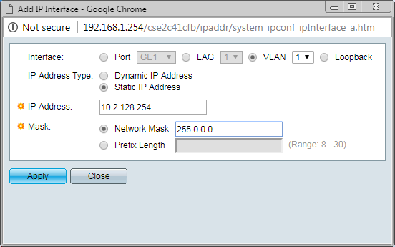
Note: Immediately upon clicking on the Apply button, the new IP address goes into effect. The result of which is the old website in the browser will stop responding. One will need to change the address in the browser to point to the new IP address, and login again, to continue with any switch configuration.
Setting up Port Mirroring for Problem Diagnoses
Port Mirroring is can be a useful diagnostic aid. With port mirroring, anything that comes or goes from a selected network port is copied to the mirror port. This allows such one to capture exactly what traffic is present at a device’s (e.g., such as an AtlasIED mic station) network interface. Once configured, one simply needs to attach a computer running a packet capture program such as Wireshark to the mirror port. Port mirroring works in either L2 or L3 system modes.
Note: You cannot set up a port used by another device in the system, such as the Announcement Controller as a mirror destination port, as this will block the device from its normal network access. You must use an additional computer or laptop to plug into the mirrored port to run tools like Wireshark.
One can set this up by going to the (1) Administration section, (2) Diagnostics sub-section, (3) Port and VLAN Mirroring topic, and (4) clicking on the Add… button on the right. These steps are shown in the screen shot below.
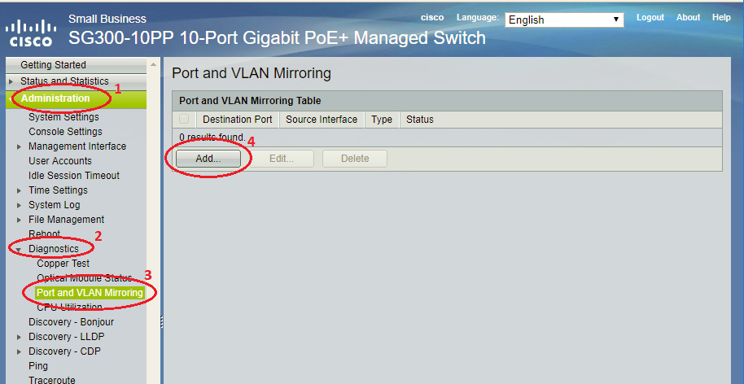
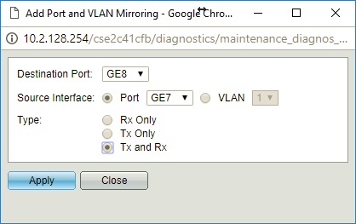
The Add… button brings up pop-up as shown at right. One should select the Destination and Source via the drop lists provided (in this example, mirror port 7 over to port 8). Usually, you will want to check the radio button beside “Tx and Rx” in order to capture traffic going both directions. Finally, click on the Apply button to save these settings.
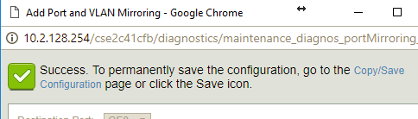
Clicking on Apply does NOT close the pop-up, but adds the notification as shown at right. The mirroring is now in effect, but will revert back next time the switch is reset or power-cycled. To make this change permanent, one should click on the blue text “Copy/Save Configuration” shown in the success message.
This action will first prompt you to auto-close the dialog box, to which you should approve. Then, it will take you to the section in the switch configuration for copying the current configuration into the startup/default configuration, as shown in the screen shot below. Click on the Apply button here to make these changes permanent. If you don’t want to do this, but find the flashing Save icon at the top annoying, there is a button for that on the bottom of this page as well.

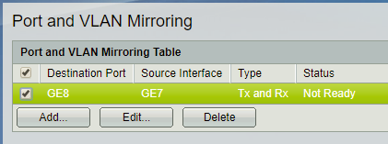
Whether made permanent or not, port mirroring is now in effect. If you want to remove this mirroring, one first clicks on the checkbox on the line that shows the mirroring, and then clicks on the Delete button. This action will show another Success Message at the top, similar to the example above, also with a link to the Copy/Save Configuration page.
Note: When Port Mirroring is in effect, there is nothing in the obvious places such as the Port Management, Port Settings page that tells you this is the case. The mirror source and destination port look the same as they always do on this page. The only place to see this is the case is on the Port and VLAN Monitoring page under Diagnostics. Therefore you might want to put in a “reminder” such as changing the Login Banner underAdministration -> System Settings (the same place that L2/L3 mode is set) to reflect these custom settings. Then, every time you log into the switch, you will see this reminder on the login page.
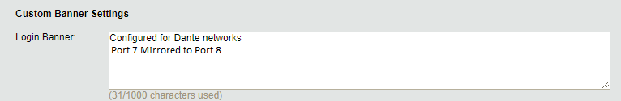
Switch Setting for Dante Network Traffic
This section demonstrates the configuration procedures for setting up a Cisco SG300-10 10 port switch for Dante Audio. Switches from different manufactures have similar interfaces (and terminology) so the steps described here are useful for configuring non-Cisco switches as well.
Green Ethernet
Green Ethernet, EEE (Energy Efficient Ethernet), or IEEE 802.3az reduces device power consumption when network traffic is low. This feature is incompatible with real time applications, such as audio or video streaming, and can lead to degraded clock synchronization and audio interruption.
Navigate to Port Management > Green Ethernet > Properties and disable this feature by turning off Energy Detect Mode, Short Reach, and 802.3 Energy Efficient Ethernet (EEE) as shown in the figure below. Click Apply to commit the changes.
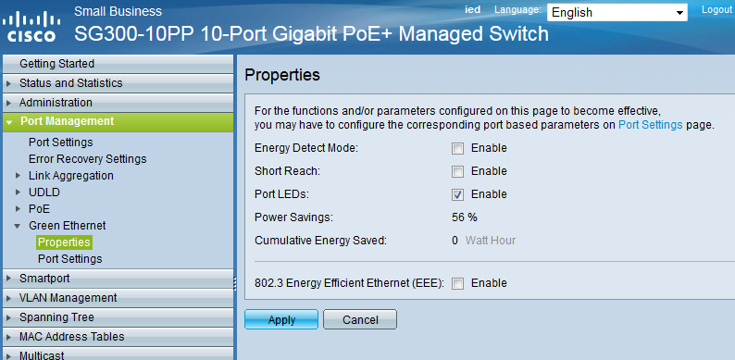
IGMP Snooping
IGMP Snooping allows a network switch to listen in on the IGMP (Internet Group Management Protocol) conversation between hosts and routers. By listening to these conversations the switch maintains a map of which links need which IP multicast streams. Multicast traffic may be removed from the links that do not need them and thus IGMP controls which ports receive specific multicast traffic. This ensures that Dante enabled devices are not overwhelmed with network traffic when they are not receiving or transmitting audio.
The following steps detail setting up IGMP Snooping on the switch:
- Navigate to Multicast > Properties.
- Select the Enable check box next to Bridge Multicast Filtering Status. Select the VLAN ID for the Dante/Audio network if not already selected to the default value of 1. Set Forwarding Method for IPv6 and Forwarding Method for IPv4 to IP Group Address. Click on Apply. The Properties page should appear as shown in the Figure below.
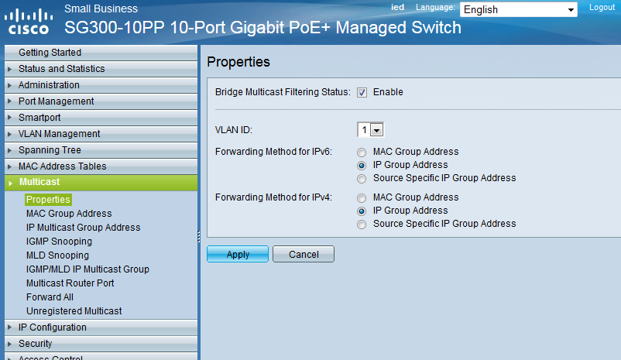
- Next, Navigate to Multicast > IGMP Snooping. Select the Enable check box next to IGMP Snooping Status, and click Apply.
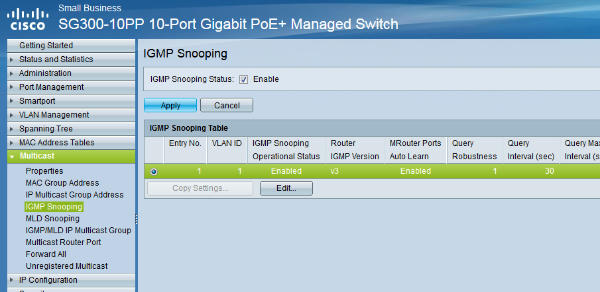
- Edit the IGMP Snooping settings by selecting the first entry (or the correct VLAN ID for the Dante/Audio network) from the table titled IGMP Snooping Table and clicking Edit. Be sure to disable/turn off popup blocker on the browser as the Edit button opens up a new popup window for editing IGMP Snooping settings as shown in the figure below.
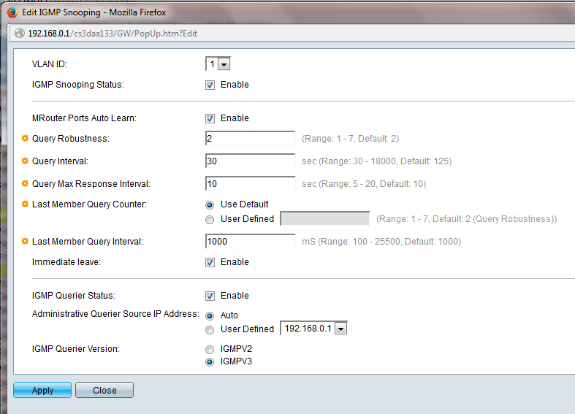
- On the Edit IGMP Snooping window (figure above), select the Enable check boxes next to IGMP Snooping Status, MRouter Ports Auto Learn, and IGMP Querier Status.
- Set the Query Interval to 30 (seconds) and set IGMP Querier Version to IGMPV3. Dante supports both IGMP V2 and V3, but all switches in the network should be running the same version. Select IGMPV2 as the IGMP Querier Version if the network includes switches that only support IGMP V2.
- Click on Apply and then the Close button to close the popup window. The switch is now setup for IGMP Snooping.
QoS (Quality of Service)
QoS is a feature that allows a network switch to prioritize data based upon its type and purpose. QoS standards were created to ensure reliability of audio on a data network in applications such as telephony, conferencing, and VOIP. Dante uses these same standards to prioritize audio, clocking info, etc.
The following steps detail how to configure QoS on the switch:
- Navigate to Quality of Service -> General -> QoS Properties.
- Enable QoS by setting Qos Mode to Advanced as shown in the Figure below.
- Click on Apply.
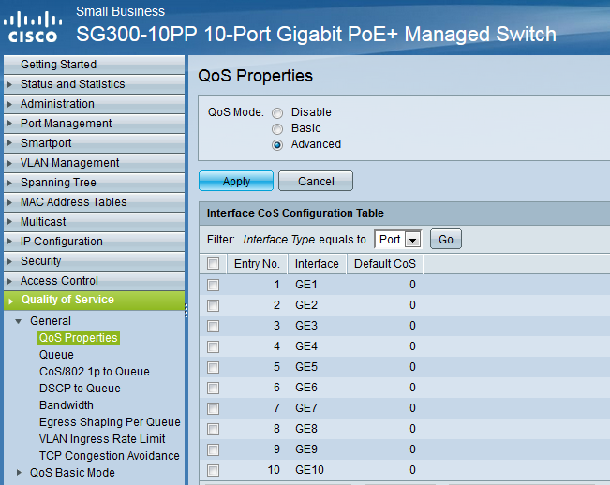
- Navigate to Quality of Service > General > DSCP to Queue.
- Specify the queue priority for each DSCP label; for this switch, 1 is the lowest priority, and 4 is the highest priority. On a dedicated Dante network, set 56 (CS7) to value 4, 46 (EF) to value 3, 8 (CS1) to value 2, and everything else to value 1, as shown in the figure below. In a network that includes other systems besides Dante (for example, a pre-existing LAN VoIP telephone system), these settings may need to be adjusted slightly. Discuss the specifics with your network administrator.
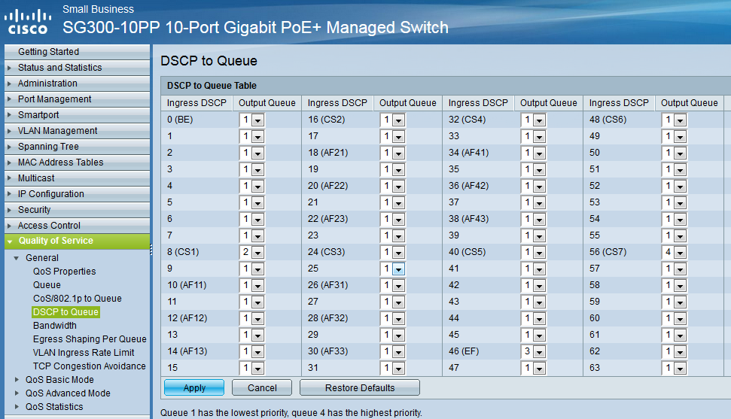
- Navigate to Quality of Service > QoS Advanced Mode > Global Settings. Set Trust Mode to DSCP and the Default Mode Status to Trusted as shown in the figure below.
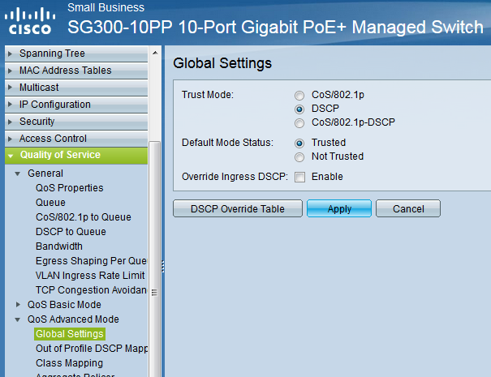
- Click on Apply. The QoS settings on the switch are now correctly configured for Dante audio.
Saving Switch Settings
The steps described above for configuring the switch are held in volatile/runtime memory and will be lost when the switch is power-cycled. Perform the following steps to save the runtime configuration to the permanent flash memory on the switch:
- Navigate to Administration > File Management > Copy/Save Configuration. Alternately, when a Success Message displays a blue text link “Copy/Save Configuration”, one can click on it to immediately jump to this page.
- Select Running Configuration for Source File Name. Select Startup Configuration for Destination File Name. The Copy/Save Configuration page should look like the figure below.
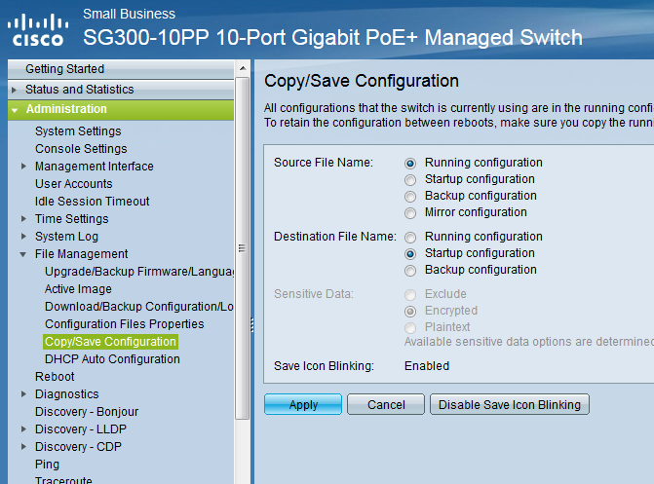
- Click on Apply.
- Click on OK on the confirmation pop-up window (if presented) to complete the task.
Setting up VLANs on a Switch
There are many ways to do VLANs. This section will cover the most typical approach, segregating the switch ports into different VLANs. At its most basic level, a VLAN is the equivalent of having separate network switches: some with one set of devices and some with the other devices on them. That is, it is just like having two (or more) separate LANs (Local Area Networks). The separation isolates broadcast traffic to be just on its own LAN/VLAN. VLANs is NOT the same as subnet addressing, like 10.x.y.x devices and 192.168.x.y devices on the network. These different “address spaces” can co-reside on the same LAN or VLAN. However, to effectively route between VLANs, it is necessary to put devices on each VLAN on different address spaces. That lets each device’s network stack know that it may be necessary to talk through the “default router” to reach an address not in the same address space as one’s own.
There are three parts to setting up typical VLANs:
- Create (define) the actual VLANs – basically give each VLAN a name and a number.
- Assign switch ports to the VLANs
- If the switch is in Layer 3 System Mode, assign IP addresses for the switch on each VLAN.
Create the VLANS
The switch always comes with one default VLAN labeled number 1. You can/should leave this VLAN alone. To add an additional VLAN one should click on (1) VLAN Management section, (2) VLAN Settings topic, and the Add… button.
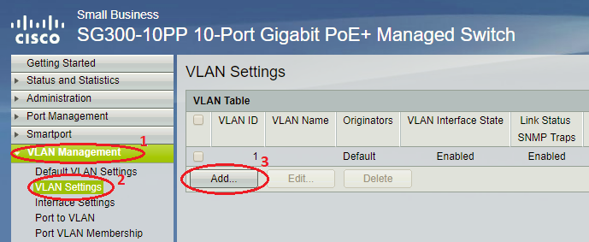
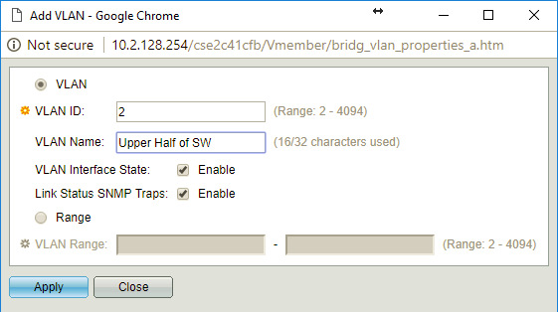
This brings up the pop-up as shown at right. One should enter a VLAN ID and optionally a Name, and be sure to check the Enable buttons. Then click on the Apply button and Close button. You can wait to save the configuration until all the other steps (below) are completed.
That is all it takes for this step.
Assign Switch Ports to VLANs
Now, one needs to tell the switch which ports should be on the new VLAN. This is done by clicking on: (1) VLAN Management section, and (2) the Port to VLAN topic. Then, one selects the VLAN ID in the (3) droplist box at the top followed by the (4) Go button. This action reloads the interface listing below it. Now one can go down the list and select which ports are not excluded from this VLAN. For our applications – particularly when there are CobraNet devices on the ports – one should always select the “Untagged” option from the (5) droplist for each port. After selecting ports, one can press the Apply button to save the changes.
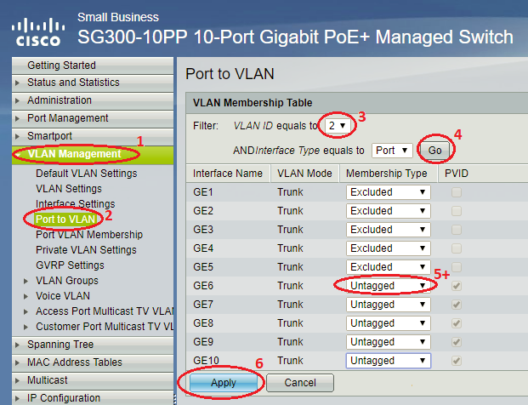
If one is going to do the next step, then it is not necessary to permanent save the configuration yet.
Note: If the computer being used to do this switch configuration is not on a port that is still a member of VLAN 1, then access will be lost at this point. After the next step is done, it will be possible to access the switch from either VLAN, using the appropriate IPv4 address for the switch for that VLAN.
Set up IPv4 Addresses for VLANs
Setting up IPv4 Addresses for each VLAN allows the switch to become the “default router” on each VLAN, so if a device wants to reach over to devices on the other VLAN, it can direct the requests directly to the switch at the local address, and have it route the requests over to the other VLAN. This is handled in the IP Configuration section, IPv4 Management and Interfaces subsection, IPv4 Interfaces topic. This is the same place where a permanent IP address was assigned to the default VLAN, mentioned earlier in this document. All we are doing now is adding a permanent IP address for the new VLAN(s). One clicks on the Add… button just as described earlier. This brings up the pop-up as shown below. The key thing now is to be sure to select the VLAN ID in the droplist near the top. Then, enter the new IP address and Network mask. Then click on the Apply and Close buttons.
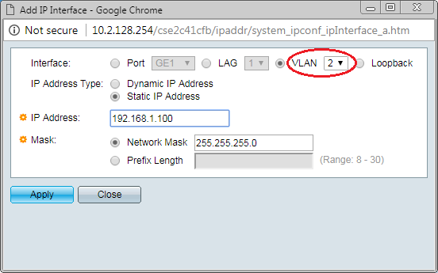
After this new address is added, one should see multiple entries in the IPv4 Interface area, such as the example shown below.
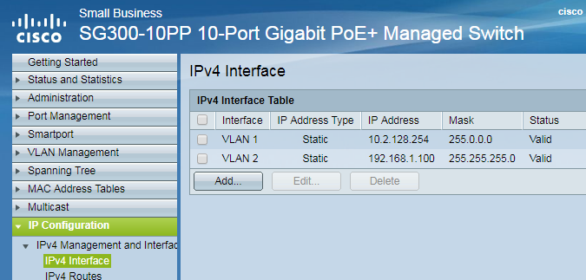
To complete the system configuration, now one has to access each device and put the above default router information into it, appropriate for the VLAN it resides on.
Of course, to make these changes persist through a power cycle, one needs to click on the (flashing) Save icon or other prompt to go to the Save Configuration page as described previously in this document.

