Troubleshooting Com Port Issues with 1200LIR Device

15 Jan 2020 KAtench
Introduction
In IP100 series units (and earlier 1200ACS units), the IED 1200 LIR (Logic Input/Relay) Service talks to two devices, the logic input collector and the relay output device. These devices appear in Windows as two (USB) COM ports, typically COM3 and COM4, but could be any numbers. There is no definitive way to determine in all circumstances which device/port is which, so instead the LIR service requires that Windows be configured such that the logic device is first and the relay device is second.
Up until now, there has been some confusion about what “first” and “second” mean in the above statement. As per earlier instructions from Engineering, it is not the actual com port number, but how the devices are enumerated (listed) internally in Windows when the LIR Services requests a list of devices of this type (FTDI chip-based devices). This order is not evident in the Device Manager, so the new method for determining this is to use the LIR service itself, as detailed in this write-up.
This need for strict ordering of devices in Windows is why the factory install procedure involves removing the jumper that enables the Relay device portion of the LIR module so the Logic Input portion gets discovered first. There is a work-around as described in the third section of this write-up that may be used when one doesn’t wish to remove the cover. The last section of this write-up is a totally optional procedure for cleaning out old com port devices so the LIR devices can be re-numbered as lower-numbered ports (e.g., 3 and 4 rather than 9 and 10).
Also, the next section covers a recently discovered situation where on some 64-bit Windows systems, the LIR Service is not able to always fully communicate with the (32-bit) FTDI driver and gets bad information back from it. This condition and how to correct it is also covered in this write-up.
Determining If LIR Devices in the Right Order
To begin, be sure there are no closures (or no connections) on the Logic Input section of the LIR. The LIR service should report no button closures in this case. When it mistakenly tries to read from the relay device, it will incorrectly report all eight buttons/closures.
There are multiple ways to do find out what inputs the LIR Service is seeing. Perhaps the easiest way on an IP100 series unit is to go to the System I/O menu option on the front panel. With nothing connected, one should see the display on the left. If there is a com port issue, one will see the all-button display on the right.
I:--------
O:--------
I:12345678
O:--------
Good Bad
Of course, when remoting in to a system in the field, seeing the front panel is not an option. The next easiest approach in this case is to query the LIR service via a new web browser tab using the following address: (This and other queries are documented in the Zendesk article: Diagnostic Aids For GLOBALCOM System Supervisor And LIR Service.)
http://localhost/lir/debug/inputs
Unfortunately, neither of these approaches tells you what the cause of the problem is, and currently there are three known causes:
- The Logic and Relay device order is wrong (i.e., the relay device comes first)
- The LIR Service is having difficulties reliably communicating with FTDI driver
Note: If the system is an older (pre-blue box) system running 32-bit Windows, this cause cannot happen.
- The Logic section of the LIR unit is bad (or the internal USB ribbon cable is not connected)
The definitive way to determine the cause is to run the LIR Service in console mode. This is done by doing the following:
- Go into Windows Services and stop the 1200LIR Service
- Open a command window and go to the LIR Service directory (C:\IED\Services\LIRservice).
A handy way to do this from Windows Explorer is to go to C:\IED\Services and hold down the shift key while right-clicking on the LIRService folder. Select the option Open Command Window Here (about the fourth one down).
- Next, run the service in console mode via the command:
LIRservice /console
In the beginning of the console output, one should see text such as below:
1200LirService Verbose: 0 : WireUp() Called
Subunit 1 found. Description = FT232R USB UART. Serial Number = A5024SNO
Subunit 2 found. Description = FT232R USB UART. Serial Number = A5024SNP
Removing Non-FT232R USB UART subunits from the list
1200LirService Verbose: 0 : Subunit information:
Note, 2 devices found
And both COM Ports are non-zero.
A5024SNO : FT232R USB UART
A5024SNP : FT232R USB UART

Subunit 1 opened. Handle = 10583488. COM Port = 9
Subunit 2 opened. Handle = 10583680. COM Port = 10
1200LirService Verbose: 0 : HardwareDriver.Activate: Activate relays - 8 tag - 8
The real console output will scroll a bunch more stuff out initially, so you may have to scroll back to see the beginning stuff as shown above. If problem cause #2 is occurring, you will see the first COM port as zero. If problem #3 is occurring, you will not see either or both device serial numbers in the early lines.
So, if you’ve eliminated causes #2 and #3 from the list, you can verify that the LIR service is correctly reading the logic input section by looking lower down in the console listing for responses to the message 0x1000. These only occur when the vACS polls the service about every 30 seconds, so it may not appear right away. A good response is shown below.
1200LirService Verbose: 0 : 0x1000 Message Received.
1200LirService Verbose: 0 : Response: 00-00
The two bytes in the response (00-00) mean ACK and zero buttons pressed (contact closures). This means the system is good as far as devices and com port assignments go. Just like verifying good on the front panel.
If instead you see the below response:
1200LirService Verbose: 0 : 0x1000 Message Received.
1200LirService Verbose: 0 : Response: 00-08-01-02-03-04-05-06-07-08
This means all buttons (contacts) are active and you have cause #1. Note, the other causes often show this same symptom of all buttons/contacts, which is why you eliminate causes #2 and #3 with the checks of the first few console output lines before moving to this step.
After you’ve made these checks, stop the service by typing “Q” in the command window. Then, you can restart the LIR Service in its non-console mode in the Services window. The next two sections discuss correcting causes #1 and #2. Correcting cause #3 is the obvious approach of checking the internal USB ribbon cable and relay power jumper, or just replacing the LIR module completely. Cause #3 is listed last because experience has shown this to the be rarest of the causes found in practice.
Correcting Cause #1 – Swapping Devices
There are two ways to get the LIR devices back into the correct order.
Method 1 is to basically repeat the factory setup procedure:
- First delete both com ports in Windows Device Manager by selecting the com ports and hitting the <Delete> key on the keyboard.
Note: Do NOT check the box to remove the driver.
- Open the case and remove both the USB ribbon cable and the relay power jumper (two-pin shunt on the lower board) from the LIR module.
- Connect only the USB ribbon cable and wait until you see a com port get added in Device Manager.
- Now, plug in the relay power jumper and wait until you see the second port added in Device Manager
Method 2 can be done entirely from within Device Manager and consists of the following steps:
- Delete the com port that was listed first in the LIR Service in console mode (e.g., Com9 in the example above). Note: Do NOT check the box to remove the driver.
- Click on the Action menu → Scan for hardware changes option.
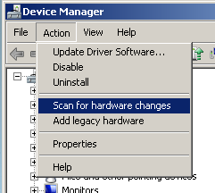
- Wait for the port to be re-discovered.
Optionally, between the first two steps, one could re-assign the remaining device to a lower numbered com port, such as the one just deleted or even lower, like Com3. If the desired port, e.g. Com3, does not show as available, one may need to delete old inactive devices as per the procedure in a later section of this write-up.
Correcting Cause #2 – Fix FTDI Driver Comm Issues
If you have determined that you have problem cause #2 and are running on a 64-bit Windows platform, you can correct this problem by doing the following:
- Put the Microsoft utility CorFlags.exe onto the system, either in a directory in the command line path or in the LIR Service directory itself. This file is originally from a Microsoft SDK (Software Development Kit). A copy was put on Zendesk with the article that has this document.
- Stop the 1200LIR Service in the Services window
- Go to a command line in the LIR Service directory. (Get to the directory as noted above for running the service in console mode.)
- Type the following command:
Corflags /32bitreq+ LIRService.exe
Note, it is important to have the plus (+) sign as part of the flag. This means ADD the flag to the executable. If this is left out, then the utility will delete all other flags and only set this one flag, with unknown consequences.
After setting the flag, one can run the LIR Service in console mode right in the same command window and verify that none of the com ports are zero any longer, and then verify that problem cause #1 does not exist.
Deleting Obsolete/Inactive Devices in Windows
If one notices that the LIR devices are at higher numbers com ports and there appears to be nothing assigned to lower numbered com ports, the system may be in a condition where previous devices with different serial numbers were attached to this motherboard (or a motherboard from which the Windows image was made). Also, these devices were never deleted from Windows and so are being held open in case the USB device is plugged back in. This is why your desktop computer quickly recognizes different USB drives you plug into it, without going through the time/effort to install/configure the driver software. However, in the case of old LIR modules and old Crystalfontz displays, these devices probably are never coming back to be connected to this system and so these “reservations” just use up com port numbers.
Old inactive devices can be deleted from Windows as follows:
Or put these commands into a batch file followed by the command “exit” to terminate the batch file. Then run the .bat file.
- Run the following commands in a command window:
set DEVMGR_SHOW_NONPRESENT_DEVICES=1
start devmgmt.msc
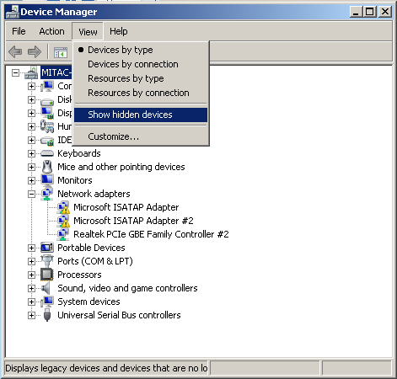
- In Device Manager, go to the View menu → Show hidden devices option.
- Now, in the Ports section, one can see the formerly hidden devices with lighter gray icons as shown below.
- Click on each formerly hidden device and press the <delete> key on the keyboard.
Note: Do NOT check the box to remove the driver.
Now one can use these com port numbers for the LIR devices if desired.
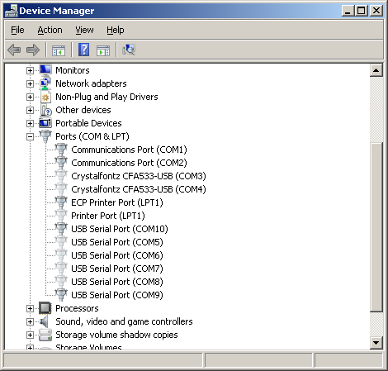

If you research this topic online, you will also find the flag /32bit+ also exists and seems to work about the same. Apparently, this flag means 32-bit execution is suggested/preferred, not that it is required as indicated by the flag shown in the instructions.

